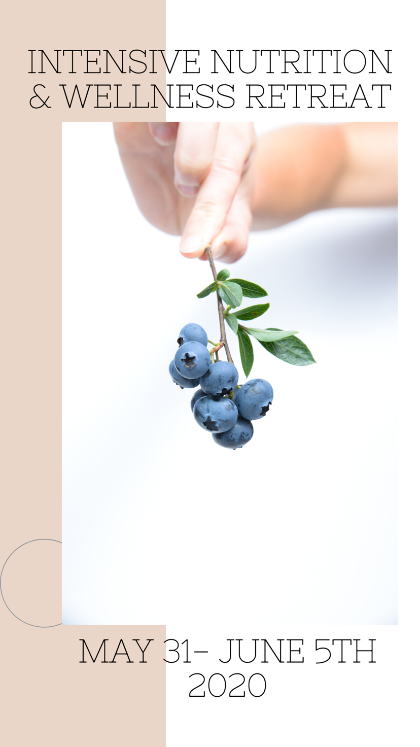
Welcome to the all-inclusive 6 Day Intensive Nutrition Retreat!

Together we will experience:

- Whole-Food Plant Based Nutrition Education

- Work with Healing foods for chronic illness/autoimmune disease

- Learn through hands on recipe classes

- Stretch and move through Restorative Yoga poses

- Learn breathwork techniques that we can use daily

- Meal prepping made simple for you and your loved ones

- Learn how to create beautiful artisanal farmer’s boards and take a handmade board home with you

- Learn about health care through your home & hygiene products

- Explore Nature

- And much more!

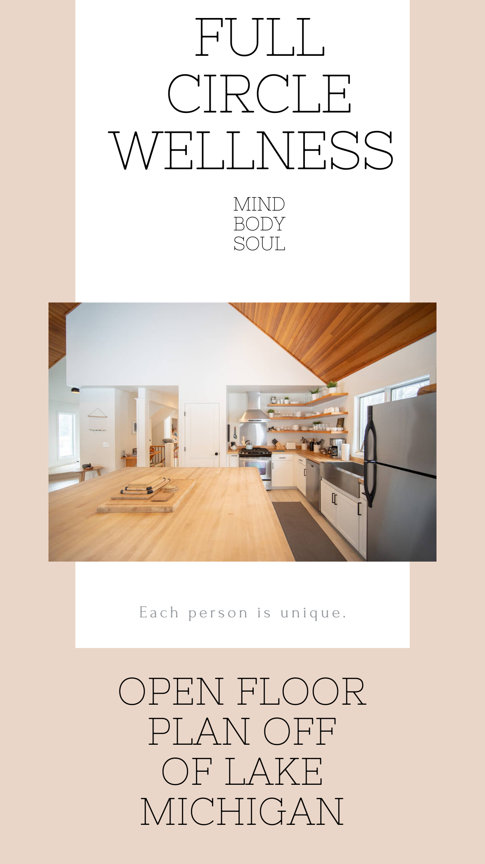
Eating well is our gateway to full circle healing and wellness.
When we support our physical self with nutrient dense foods,
we cleanse the body of unwanted toxins that block our emotional,
mental, and spiritual health.

Learn about the connection that food has through these education & discussion based topics:

- Emotional Eating
- Fear based diets
- Diet Trends
- Chakra Eating
- Eating for YOU

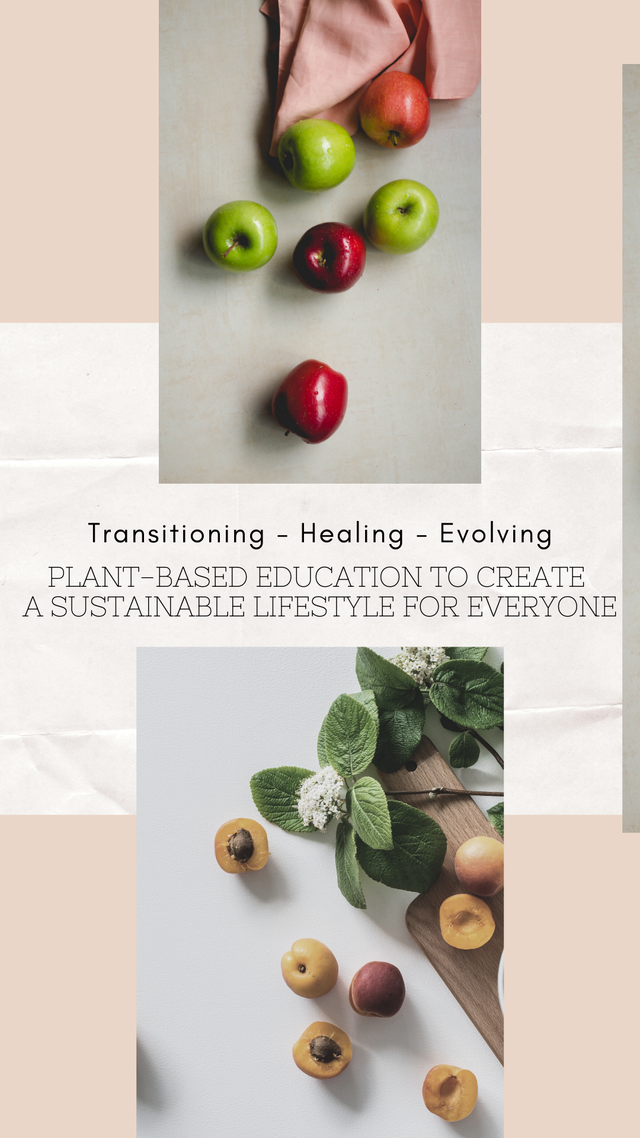
Who is this retreat for?

- Those living a SAD (Standard American Diet) looking for positive change in their diet and overall health

- Those who have recently or are in the process of transitioning to a Plant-Based & Cruelty Free Vegan lifestyle

- Seasoned Vegans ready to amp up their health through implementing Whole Foods vs. Processed Vegan foods

- Those living with Autoimmune Disease, Chronic Illness, Cancer, Diabetes, and/or Heart Disease

- Those READY to create positive & sustainable change through the power of food

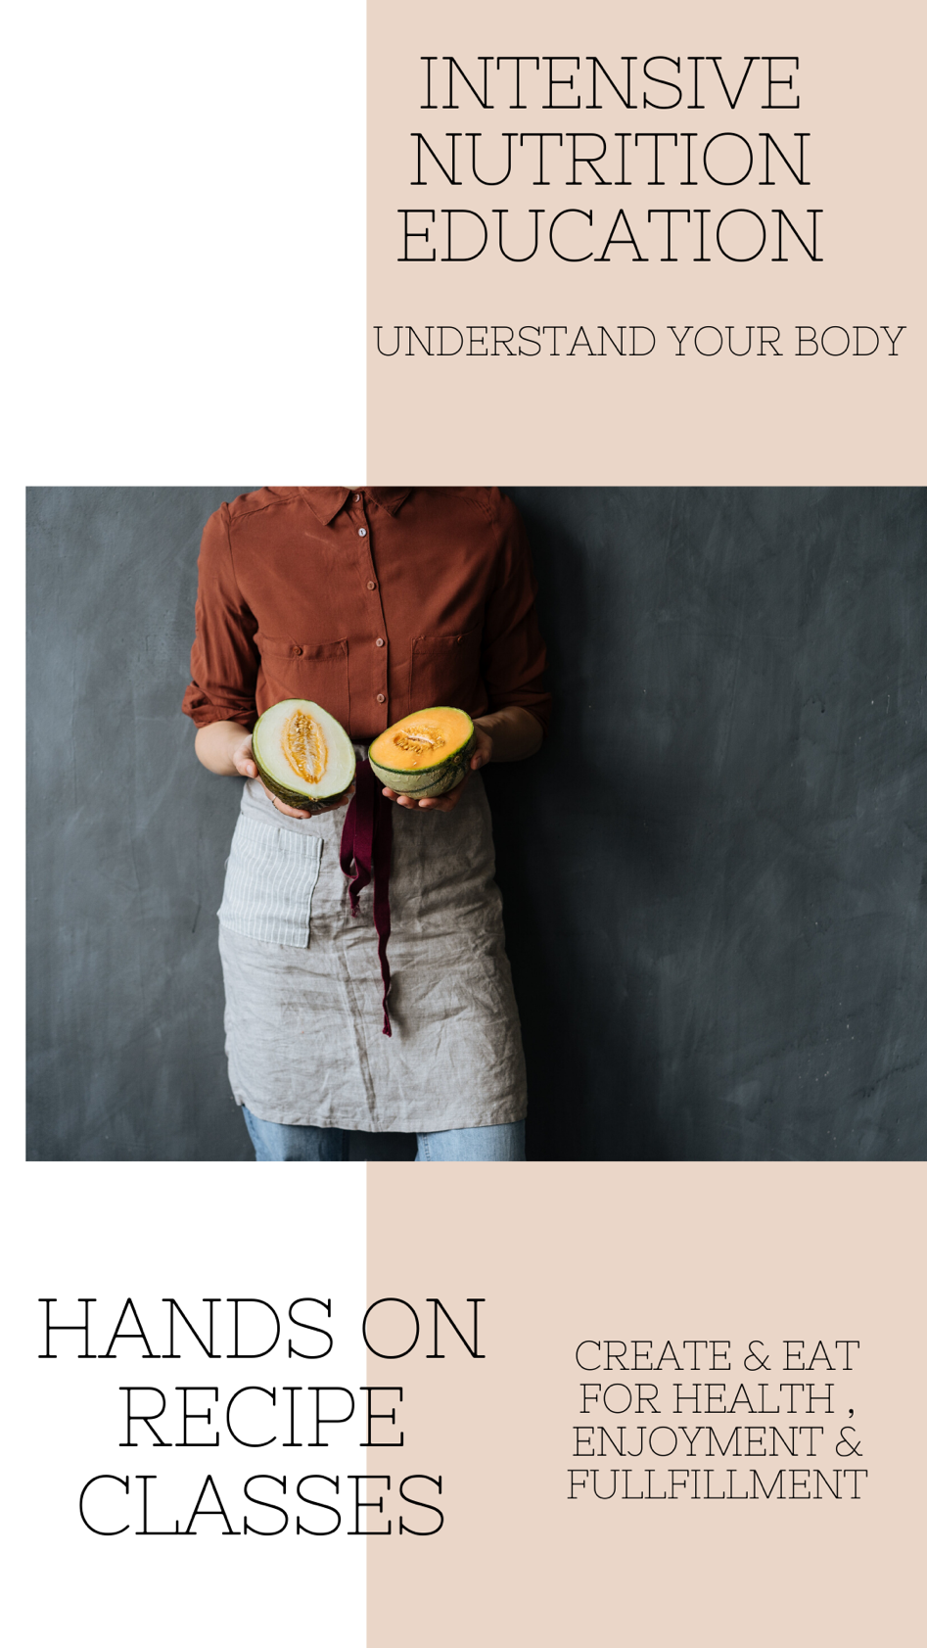

Sadly, it is uncommon to come in contact with an individual who is totally healthy across the board.

It is all too common we as a collective are walking around in a daze, foggy brain, chronic bloating, sinus issues, skin problems, headaches, and the list just goes on.

We live in an adrenaline, fight or flight paced generation, and we simply aren’t allowing ourselves to just STOP.

Left and right individuals are being diagnosed with some crazy Autoimmune disease and the cancer statistics just keep looking worse.

Chronic illness is managed with drugs.

Most diagnosis are delivered with a “no cure” statement.

To me, this just shouts that mainstream medicine doesn’t have the answer…but, it doesn’t mean there is no answer.

Let’s create together in the kitchen, with simple foods that are preventative and healing for these “fatal” diagnosis.

We are living in a society based around trends by marketing. This means that DIETS have been created vs healthy lifestyle. Within a diet lacks sustainability.

Sustainability is the ability for something to be maintained at a certain rate or level. A lifestyle is something we create for ourselves that involves positive consistent evolution, instead of restricting ourselves to fit into a mold then falling off the wagon.

We have seen food trends about certain allergens and food intolerances that involve gluten, soy, eggs, refined sugar, GMOs, preservatives, and artificial ingredients.

Let us take a deeper look into these foods, how they fuel chronic illness, how we can create and live without them, and how certain foods just aren’t necessary or made for the human body.

But, we should also discuss how not to live in food fear after living with allergies/intolerances, how to reverse these symptoms, and how to move forward should we choose to consume these foods.

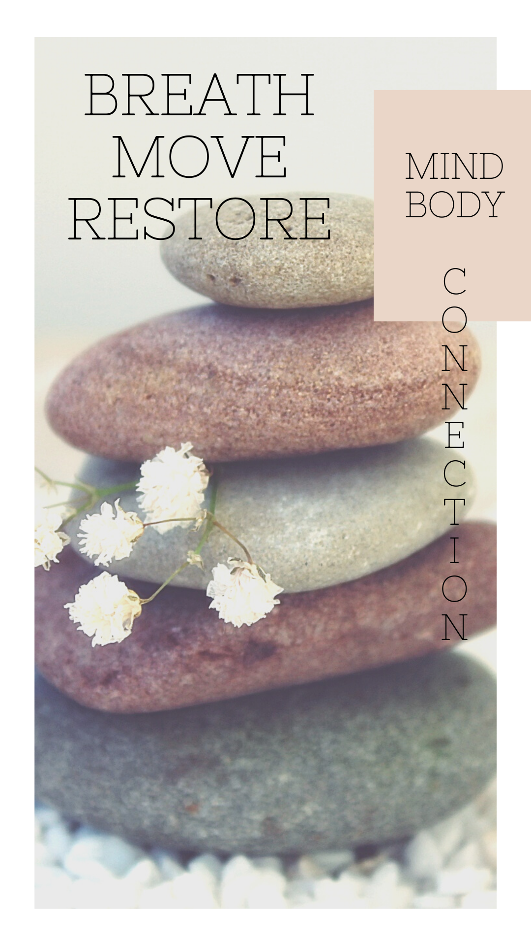
Is it common that individuals focus on their physical image in an unhealthy manner.

Many feel & believe that excessive exercise or even exercise alone is their answer to the body that will make them happy.

But, the physical self needs proper nutrition to function and thrive for any level of athletic needs.

Let’s start with understanding how food will give you the tools to thrive through:

- Movement
- Breathwork
- Meditation

And, how these tools will create access in understanding that there is a mind/body connection with the state of our emotional/physical well-being.

Yoga Instructor, Lauren J. Williams, will be joining us on the mat daily with her beautifully guided practice.
Lauren brings a sense of calm and peace to her practice and will leave you feeling refreshed, cleansed, and ready for the day!
“ I am...
Inspired by my community, art, and using movement as medicine! I love to begin my day with
my morning ritual which includes drinking tea, meditating for 20 minutes, and journaling.
At the age of 12 I was introduced to my yoga practice while training as a competitive figure skater,
and I have been in love with my practice ever since! I enjoy connecting with the youth and spreading
messages about the importance of taking the time to breathe. I am a free spirit and I deeply believe in
encouraging people to be themselves at all times! I enjoy curating experiences that will allow people
to leave feeling lighter, confident, and free.”

There is no need to feel alone on your journey.

Sometimes those closest to us have a hard time accepting the change we need for ourselves.

Know that you are not alone.

Know that it is ok to honor what you and your body need.

Because, we are all uniquely made to be just what we choose to be.

Community is support. Community is respect. Community is love.

Let’s create a community together for what you need.

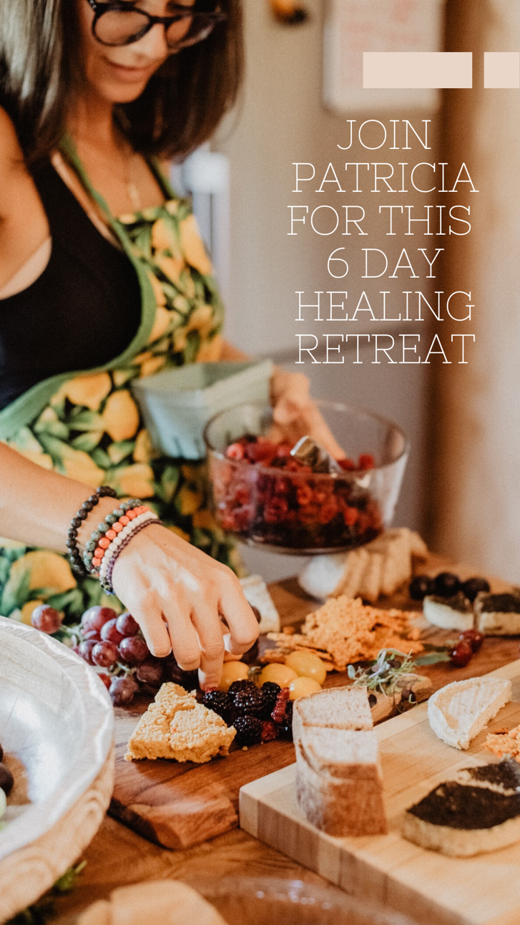
All-inclusive rates & Bed availability:

Single Twin Bed Availability: (2)
(Shared Room)

Queen Bed Availability: (1)
(Shared Room)

Queen Bed Availability: (3)
(Private Room)

PRICES PER PERSON
$2,095 (private room)
$1,895 (shared room)
$1,595 (shared bed private room)
$1,295 (shared bed shared room)

Payment Plan Options:
- $500 Non-refundable deposit to reserve your spot
- Balance can be split in two
- Part 1 Balance Due March 20th
- Part 2 Balance Due May 1

***REGISTRATION CLOSES APRIL 1st***

Refund/Cancellation Policy:
All cancellations must be by April 1st to receive a full refund of what has been paid, excluding the deposit. Anything after April 1st will provide 50% back within a 30-day period of the cancellation.

Inclusive:
Full Amenities
Three Meals Daily
Snacks/Desserts Daily
Eco Friendly Yoga Mat
Handmade Farmer’s Board
Journal
Nutrition Documents/RECIPES
Hands-On Workshops
Education-Based topics
Daily Yoga , breathwork & meditation

Take Note:

Patricia will email a coach/client contract for you to electronically sign after your initial deposit payment. Copy of contract below so you can review before placing deposit.

Registration online will consist of paying the $500 deposit and you will be invoiced the balance once you and Patricia set up your personal payment plan.

A daily schedule and suggested list of ‘what to bring’ will be sent to you a few weeks in advanced to the retreat.

A 3% charge will be added to the balance of the invoice AFTER the $500 deposit has been made, for processing fees.

Provided by Patricia Ode Wellness, L.L.C. 2018

Nutritional Wellness Coaching Agreement
This nutritional wellness coaching agreement (the “Agreement”) is entered into on this ____ day of ___________, 2020, by Patricia Ode Wellness, LLC (“Patricia Ode Wellness”) and the undersigned individual (hereinafter “you” or “your”).
1. Services. In consideration of your payment of the fee(s) identified in this Agreement, Patricia Ode Wellness agrees to provide non-medical advisory nutritional consulting by Patricia Ode (the “Consultant”) based upon whole food, plant-based nutrition (the “Services”). The Services may include, upon request, grocery shopping, inventory of kitchen and pantry staples, meal planning, recipe sharing and consultations.
2. Fee(s). You agree to pay to Patricia Ode Wellness the following [INSERT RATE ]for the Services. Unless otherwise agreed in writing, invoices will be sent via third-party payment application Paypal and/or credit card. You will be charged a three (3%) service charge for payments made electronically. Invoices are due upon receipt. Payments not received when due shall accrue interest at the rate of five (5%) percent until paid in full. Any payment returned NSF shall be subject to an administrative charge of Thirty-Five Dollars ($35.00). No refunds shall be granted. Patricia Ode Wellness may, in addition to any other remedies afforded by law or this Agreement, suspend all Services until outstanding invoices are paid in full.
3. Application to Ongoing Services. Patricia Ode Wellness may provide ongoing Services on an as-needed, as-requested basis. In such event, the terms of this Agreement shall apply unless otherwise modified, deleted or otherwise updated by Patricia Ode Wellness with prior notice to you.

4. Representations. By signing this Agreement, you represent and warrant that:

a. You understand that the Services provided by the Consultant and Patricia Ode Wellness is non-medical in nature.

b. You have stated and identified to Patricia Ode Wellness all known medical or health conditions and that such representations are true and accurate to the best of your knowledge.

c. You understand that any assessment or recommendation that you receive is solely for the purpose of supporting your overall health and is not a replacement for medical advice, examination, diagnosis or treatment. Patricia Ode Wellness has recommended that you consult with a physician prior to engaging in the Services. You understand that the Consultant is not a medical doctor and that Patricia Ode Wellness does not diagnose, cure or treat illnesses or diseases.

d. The Consultant holds a Whole Food Plant-Based Nutrition Certificate through Cornell University and is not holding herself out as a physician.

e. You will immediately notify Patricia Ode Wellness in writing of any allergies, pain, discomfort or adverse reactions that you may experience during the current session or during ongoing sessions so that Patricia Ode Wellness may modify its methods and/or recommendations to accommodate these issues.

f. You are seeking nutritional health advice at your own free will, from a holistic nutritionist, and that you are free to accept or reject this advice on the traditional (non-medical) use of nutrition, herbs, supplements, and natural therapies at any time.
5. No Guarantees; Disclaimer of Warranties. You understand and agree that neither Patricia Ode Wellness or Consultant has made or can make any guarantees or promises regarding the outcome of the Services and expressly disclaims any such guarantees or promises. TO THE FULLEST EXTENT PERMITTED BY LAW, PATRICIA ODE WELLNESS EXPRESSLY DISCLAIMS ANY WARRANTIES, IMPLIED OR EXPRESS, NOT CONTAINED HEREIN, REGARDING THE OUTCOME OR THE RESULTS OF THE SERVICES, INCLUDING WITHOUT LIMITATION THE IMPLIED WARRANTY OF MERCHANTABILITY AND FITNESS FOR A PARTICULAR PURPOSE.
6. RELEASE AND WAIVER OF LIABILITY.

a. Voluntary Assumption of Risk. You acknowledge and understand that your participation in the Services including, but not limited to, changing your diet, incorporating plant-based or whole foods, grocery shopping and traveling to and from grocery shopping centers includes a risk of serious bodily injury (including death) and loss or damage to property from, but not limited to, adverse or allergic reactions, illness, accidents and related incidents.

b. WAIVER OF LIABILITY. YOU, ON BEHALF OF YOUR HEIRS, ESTATES, ASSIGNEES AND DESIGNEES, HEREBY RELEASE FROM LIABILITY AND HOLD HARMLESS, FOREVER DISCHARGING AND PROMISING NOT TO TAKE LEGAL ACTION AGAINST PATRICIA ODE WELLNESS, ITS OWNERS, MEMBERS, EMPLOYEES, AGENTS, AND CONTRACTORS (COLLECTIVELY, THE “RELEASEES”) FROM ANY CLAIM, DEMAND, LOSS, LIABILITY OR DAMAGES (INCLUDING ATTORNEY FEES AND COSTS), WHATSOEVER ARISING FROM, RELATED TO OR RESULTING FROM THE RISKS (COLLECTIVELY, THE “CLAIMS”) INCLUDING THOSE CAUSED BY THE NEGLIGENT ACTS OR OMISSIONS OF ANY OR ALL OF THE RELEASEES, BUT EXCLUDING THOSE CAUSED BY THE GROSS NEGLIGENCE OF RELEASEES. YOU FREELY AND VOLUNTARILY ASSUME COMPLETE RESPONSIBILITY FOR ALL RISKS AND FOR ANY INJURY (INCLUDING DEATH) OR PROPERTY DAMAGE THAT MAY OCCUR TO YOU OR YOUR PROPERTY AS A RESULT OF THE RISKS, EVEN IF SUCH IS OCCASIONED IN A MANNER THAT IS NOT FORESEEABLE TO YOU AT THIS TIME. AS BETWEEN YOU AND THE RELEASEES, YOU WILL BE SOLELY AND FULLY RESPONSIBLE FOR ANY AND ALL MEDICAL COSTS YOU MAY INCUR BECAUSE OF ANY INJURY AS WELL AS ANY COSTS RELATED TO THE LOSS OF DAMAGE TO YOUR PROPERTY THAT YOU MAY SUSTAIN.

c. Indemnification. You agree to indemnify, defend and hold harmless the Releasees from and against any and all claims, demands, suits, losses, costs or expenses (including attorney fees) arising out of your participation in the Services and enforcement of this Agreement.

7. General Provisions.

a. Governing Law. The laws of the state of Michigan shall govern the validity, interpretation, performance and enforcement of this Agreement, without regard to conflicts of law principles.

b. Venue. The parties hereby stipulate that any dispute arising out of this Agreement shall be brought in a court having jurisdiction over the parties and located in Wayne County, Michigan.

c. No Assignment. You may not assign your rights or your obligations under this Agreement.

d. No Waiver. Any failure or delay by either of the parties to exercise any right under this Agreement shall not be deemed to be a waiver of such right.

e. No Modification. The terms of this Agreement may not be modified, amended or altered without a written agreement signed by both parties.

f. Written Notice. Any notice required under this Agreement shall be provided in writing delivered the other party at the electronic mail address identified below. The notice shall be deemed delivered when sent.
Patricia Ode Wellness, LLC

__________________________ ________________________
Signature Date

__________________________
Name

__________________________
Email Address for Notice

Client

__________________________ _________________________
Signature Date

__________________________
Printed Name

__________________________
Email Address for Notice

