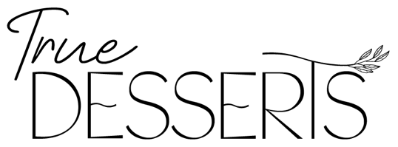
~ Plant-Based / Organic / Non-GMO / Gluten-Free / Soy Free / No Refined Sugar, Preservatives, or Artificial Ingredients ~

Catering Menu $52 p/p {75-100}
$47 p/p {125-150}

Charcuterie / Farmer’s Board Style: (Choose 7: Price goes up with additional options)
- Fully Raw Vegan in season fruit & vegetables
- Raw and cooked in season vegetables
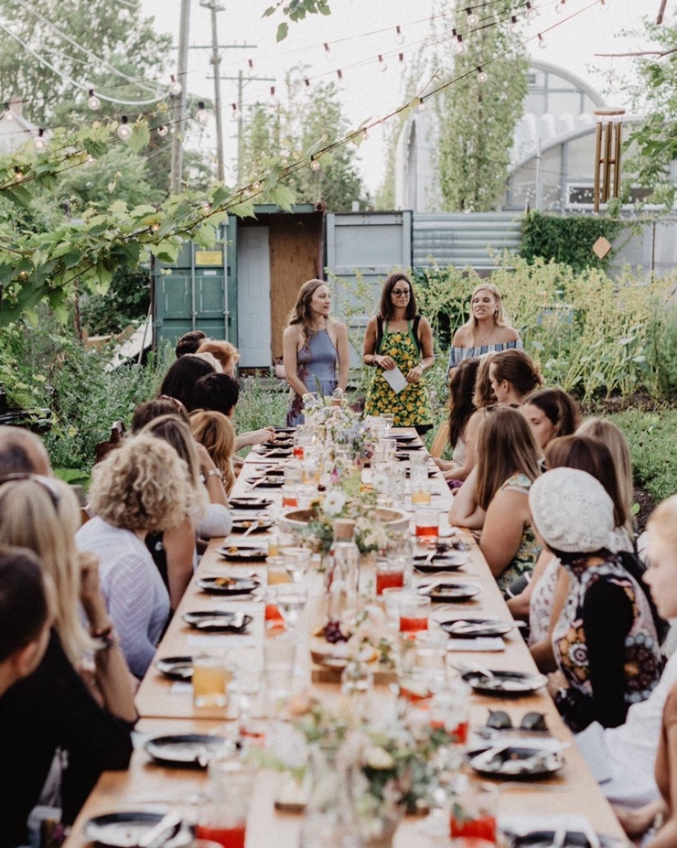
- Fruit themed displays
- Bite Sized Collard Wrap Burritos
- Raw Vegan Sushi
- Bite Sized Sandwiches (sauce, microgreens, tomato, cucumber, local bread)
- Harissa Jack Cashew Cheese
- Creamy Herb Cashew Cheese
- Black Pepper Crusted Macadamia Cheese
- Sundried Tomato Cashew Dip
- Cilantro Avocado Cream Dip
- Hummus (can be made oil free)

Salad Bar
- In Season Greens
- Creamy Kale
- Fruit Salad
- Cold Lentil Salad
- Piaz (Armenian bean salad)
- Toppings Bar: An array of salad toppings including fruit, veg, nuts, seeds
- Dressings: Creamy Cashew Herb, Lemon Garlic Tahini, Strawberry Basil

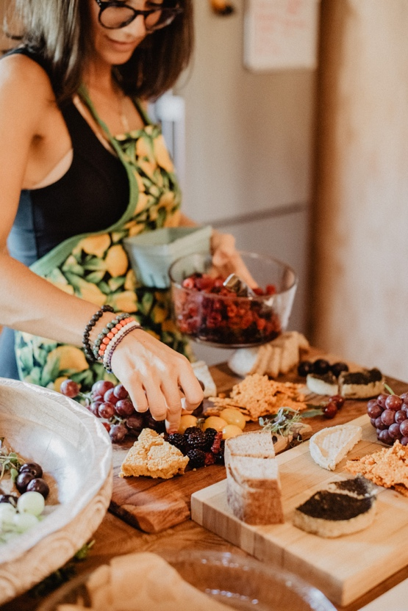
Taco & Nacho Bar
- Prepared Hard or Double Decker Tacos
- Guacamole
- Cashew Queso
- Cashew Sour Cream
- Fresh Salsa
- Tortilla Chips (can be corn free)
- Toppings Bar: Bell Peppers, Diced tomatoes, Jalapenos, Beans, Shredded Cabbage, In Season Greens

Desserts (Cupcakes, Mini’s & Slices all Raw Vegan Cheesecake)
Superfood Cupcakes ($8 p/p)
Lemon Coconut Cream Mini’s ($7 p/p)
Chocolate Mouse & Peanut Crumble Shooters ($10 p/p)
Custom Order large cake slices ($11 p/p)

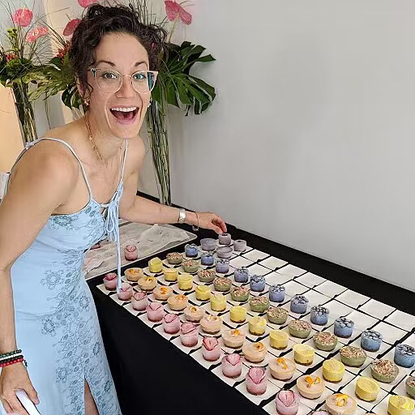
Creating for the health of your body, the animals, and the planet.

